Alexander, Judy (from MBAC Consulting and Linked In websites)
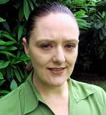
BSc Forestry ANU 1995.
Judy has over 15 years experience with the forest industry across native forests and plantations, in both public and private sector forestry throughout New South Wales, Victoria and Tasmania. She is a Registered Professional Forester (RPF), a member of Institute of Foresters of Australia and a member of Australian Forest Growers.
Senior Forest Management Planner Forestry Tasmania 2004 –2009. Forest Systems Manager Hume Forests Ltd 2009 – 2011. Managing Director Foresa Consulting December 2011 – ,

